Name: **ZOHAIB HASSAN SOOMRO**

RollNo#: **19SW42**

Subject: **Computer Networking**



Q1: Execute the above mentioned commands and display the outputs.

1. Ipconfig

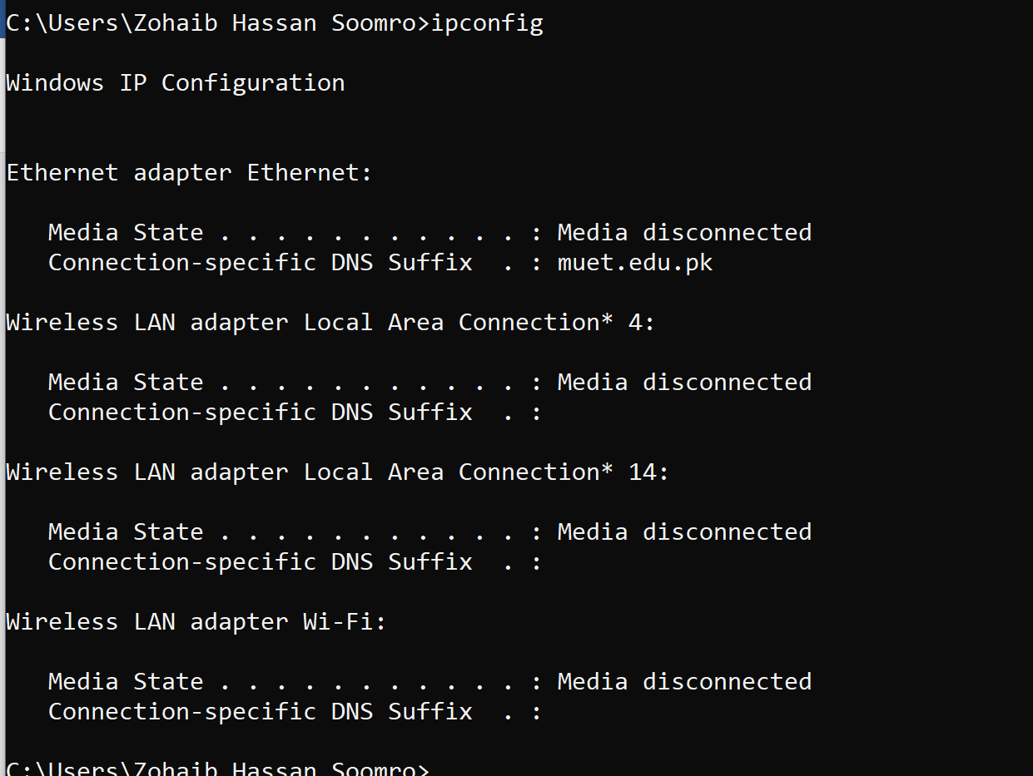

1. Ipconfig/displaydns:

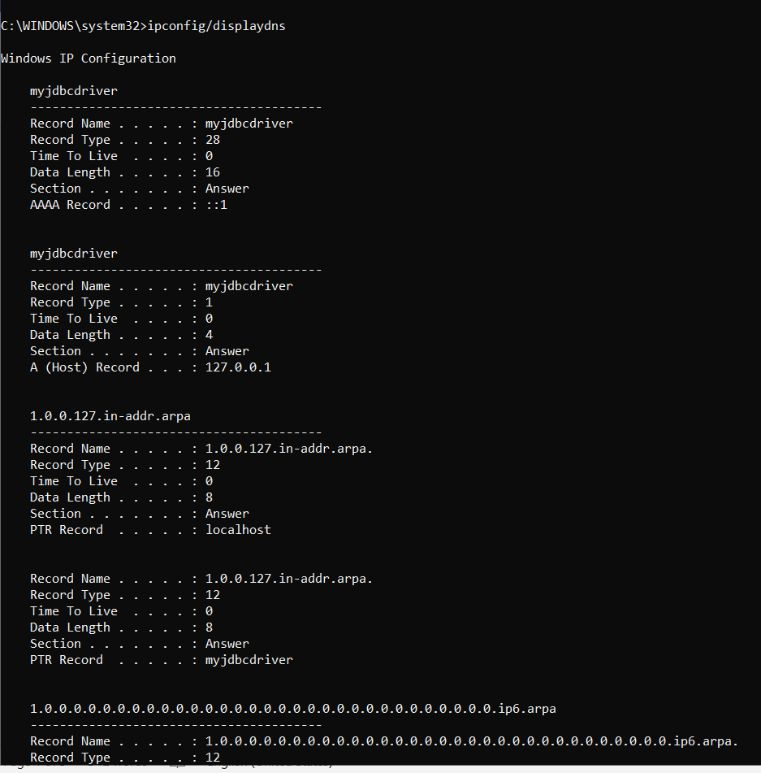

1. Ping : PACKET INTERNET GOPHER:

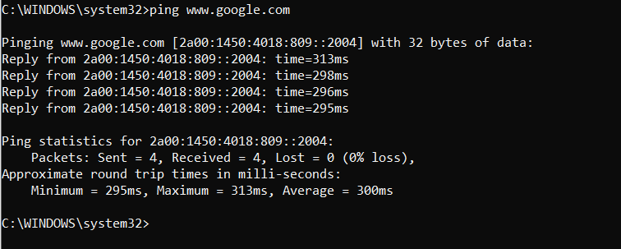

1. Tracert:

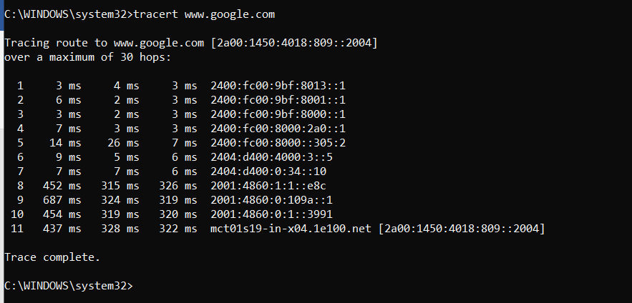

1. Arp-a:

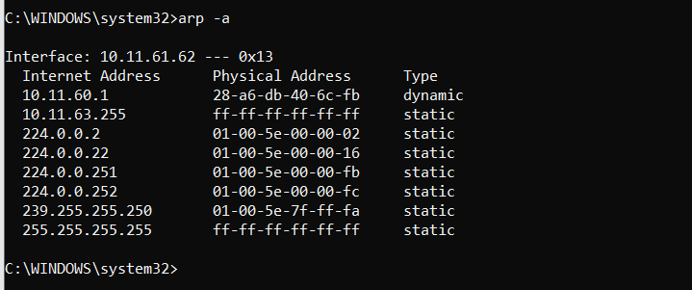

Q2**: Find and explain a network command that changes the ipaddress of your computer**

**from your command prompt. Change the ipaddress and display the output.**

Ans:

**Netsh**:

The **netsh** command allows us to configure just about any aspect of network connections in Windows e.g changing ip/dns settings etc. To work with it, we’ll need to open Command Prompt with administrative privileges.

Step-1: Know the full name of network (for the interface we want to change):

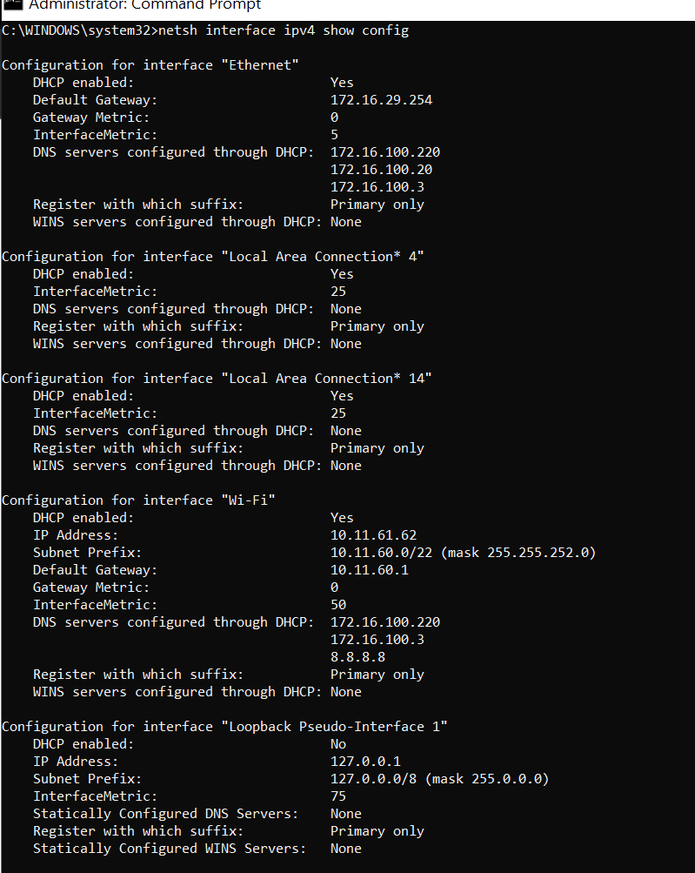

Initial IP-address

Step-2: Change ip-address(to a static ip in our case), subnet mask and default gateway:

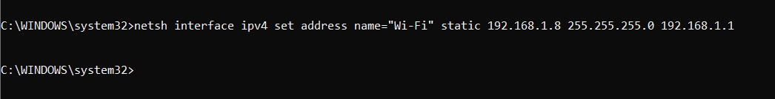

After changing IP-address:

